# **Topic: Housing Problems associated with Flooding in North Carolina**

**Authors: Andrew Mackin, Sophie Brager, Filipp Beldiushkin, Alexandra Ayala**

**Introduction**

The Atlantic Hurricane Season (from 1st of June to 1st December of each year), unfortunately, brings immense destruction to Central America, the Antilles archipelago, and the South Atlantic region of the US. One tragic case of such destruction was when Category 5 Hurricane Katrina hit New Orleans, LA in 2005, flooding 80% of the city and killing 1464 people only in New Orleans. As a result of Hurricane Katrina, more than 800,000 housing units were damaged or destroyed, leaving many people homeless and costing over 160 billion USD in 2005 (Graduate School of Oceanography). Hurricane Katrina can be considered an extraordinary case, but nonetheless, hurricanes can cause mass amounts of economic and housing damage.

This study, however, will look not at the media coverage of the major hurricanes, but at the housing problems in North Carolina that are caused by the flooding, which are most frequently caused by the hurricanes. While there has been a study that linked sea level rise with socioeconomic and racial inequality in the Carolinas, there has been no study that looked for a connection between flood zones, elevation, housing prices, and non-white population in NC (Handwerger, Sugg, and Runkle 2021). Specifically, our study's research question is 'What, if any, is the spatial relationship between flooding and socioeconomic inequality in NC?'. The main hypothesis in this study is that flooding in NC disproportionately affects low-income communities with less access to house insurance.

**Methodology**

A variety of publicly available datasets published by various departments and offices of the government of North Carolina, as well as federal government, was used.

One such dataset is provided by the Spatial Data Download tool the NC Department of Public Safety created. It allows users to download information about flooding risks across North Carolina by selecting the area of interest and choosing certain features of interest like flooding zone areas, political boundaries, buildings, etc. The research was focused on six areas: three coastal ones (around Wilmington, Elizabeth City, and Jacksonville) and three interior ones (Research Triangle Park, Charlotte, around Asheville). Among other things, this dataset contains the flood area zones designated by the Federal Emergency Management Agency (FEMA). FEMA breaks up every county and predicts the flood risks for each area. If FEMA believes that the area will be inundated by the flood event having a 1-percent chance of being equaled or exceeded in any given year, it designates this area as a Special Flood Hazard Area (SFHA). The purchase of flood insurance for the structures located in this area is mandatory, and there is a 1 in 4 chance that the structure situated in SFHA will be damaged by a flood over the normal 30-year life of the loan (IRMI). Moreover, NC Spatial Data Download provided information on floodplain mapping. This data was used to create a map of elevation levels around our interest areas. The most important layer in the spatial data is base flood elevation (BFE). BFE is used to determine the risk of flooding for building structures. If a structure is elevated above BFE, it has low risk of flooding, hence receiving lower flood insurance rates.

Another source that was used in this research was the Census Population and Housing dataset published by the NC Office of State Budget and Management. It has various data on housing in NC on a variety of spatial scales from state to census tract to municipality. The variable from the dataset that was used in the analysis for this paper is "Median Value of Owner Occupied Units." This variable shows the wealth of the residents of each county, as these residents could afford to buy, rent or take out a mortgage to be able to live in a housing unit in a county. As data for each county was not available for each year, and sometimes only for 1970, 1980, or 1990, the 2015 year was taken as a standard, and if data was only available for the years before 2015, the currency calculator developed by the American Institute for Economic Research was used to account for the inflation that has happened between the year for which data was collected and 2015.

Finally, The Climate and Economic Justice Screening Tool, developed by the federal Council on Environmental Quality, was used to understand the demographics of the chosen buffer areas. This screening tool allowed demographics of all races to be analyzed in the chosen areas to assess the economic disparities in the state better. The screening tool displayed the percentage of different racial demographics in North Carolina.

**Results**

SFHA areas were mapped using the Categorized symbology, where pink depicts the SFHA areas (Figure 1). Here, even though some pink can be seen in coastal NC, in inland NC there is barely any pink.

Then "select features using expression" was used in the attribute table of base flood elevation to calculate the average elevation in each area of interest. Here are the results:

| Wilmington | 29.68 feet | Elizabeth City | 17.63 feet |
| --- | --- | --- | --- |
| Research Triangle Park | 276.18 feet | Jacksonville | 33.04 feet |
| Charlotte | 652.28 feet | Asheville | 2221.83 feet |

The map (Figure 2) demonstrates the percentage of properties within the census tracts of North Carolina which are projected to experience flood damage in the next thirty years. The blue color ramp is used for the percentage, while the green lines are made with a buffer around the red points which represent the cities of interest. Those green lines border the census tracts in the areas of interest, although there may be some which are not accounted for as a result of using a buffer instead of selecting all the census tracts for each county being studied. The areas of interest which are projected to have the greatest amount of property damage are near Asheville, Elizabeth City, and Wilmington. Jacksonville comes next, and the areas near Charlotte and RTP are projected to experience the least flood damage with regards to the percentage of properties which would experience flooding.

The next map (Figure 3) was created using data from the Climate and Economic Justice Screening Tool to show the low-income population distribution throughout North Carolina. The map shows the census tracts in North Carolina with the percentage of their populations that are low-income indicated by a red color ramp. The census tracts in the areas of interest are mostly outlined in green using a buffer from the cities of interest which are listed above and shown as blue points on the map. It shows that the areas of interest with the highest low-income percentages are near Wilmington, Jacksonville, and Asheville. The areas of interest near Charlotte and RTP seem to have much lower percentages of the population in those census tracts overall which are low-income. The area near Elizabeth City is in between the two ends of the spectrum.

Using the census data, the average "Median Value of Owner Occupied Units" was found across counties in each area of interest that was selected for our research. It was discovered that the areas around RTP and Jacksonville are the most economically privileged. while Elizabeth City and Charlotte have the most economically disadvantaged residents. The median value of owner-occupied housing units turned out to be the following:

| Wilmington | 132270 USD | Elizabeth City | 111448 USD |
| --- | --- | --- | --- |
| Research Triangle Park | 162081 USD | Jacksonville | 142580 USD |
| Charlotte | 118073 USD | Asheville | 131178 USD |

Correlation analysis was also conducted to find how flooding data correlates with key socioeconomic parameters. A strong positive correlation (coefficient = 0.984) was found between the percentage of an area designated as SFHA and whether the region of study is coastal or inland. A strong negative correlation (coefficient = -0.742) was also found between the percentage of an area designated as SFHA and the average elevation. Moreover, a weak negative correlation (coefficient = -0.199) was discovered between the percentage of an area designated as SFHA and the median value of owner-occupied housing units in 2015 USD.

Linear regression analysis was also conducted to complement the correlation analysis. Specifically, a linear regression model, in which the dependent variable is the percentage of the area of state designated as SFHA and the independent variable is the median value of owner occupied units in 2015, was built using the sklearn library in the Python programming language. R-Squared value (statistical measure representing the proportion of variance in the the dependent variable that is explained by the independent variable) is 0.039, which suggests that there is no linear regression relationship between the percentage of the area of state designated as SFHA and the independent variable is the median value of owner occupied units in 2015. As evident from Figure 4, this might be the case because the sample size is quite small (only 6 regions of interest were analyzed).

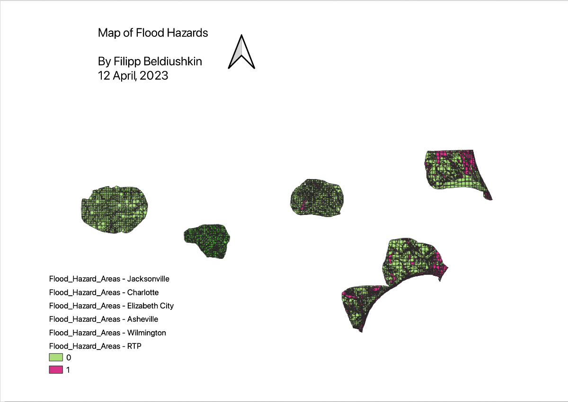

***Figure 1: Map of Flood Hazards in NC***

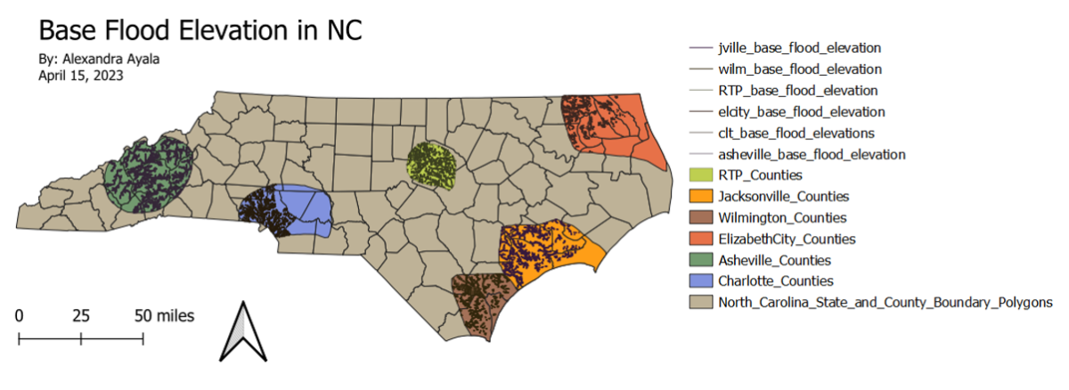

***Figure 2: Base Flood Elevation in NC***

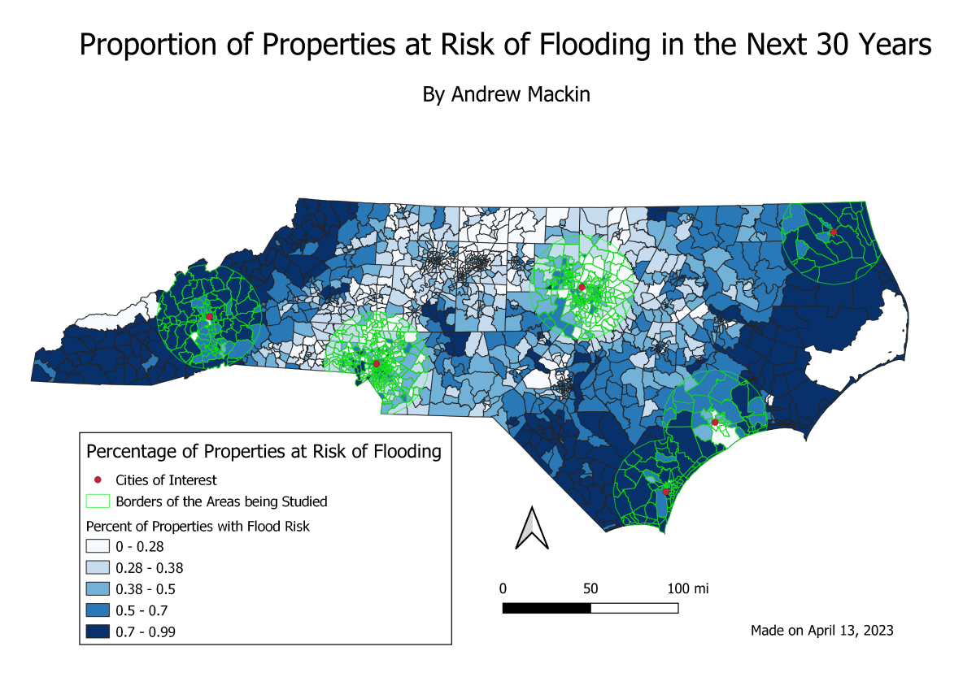

***Figure 3: Proportion of Properties at Risk of Flooding in the Next 30 Years***

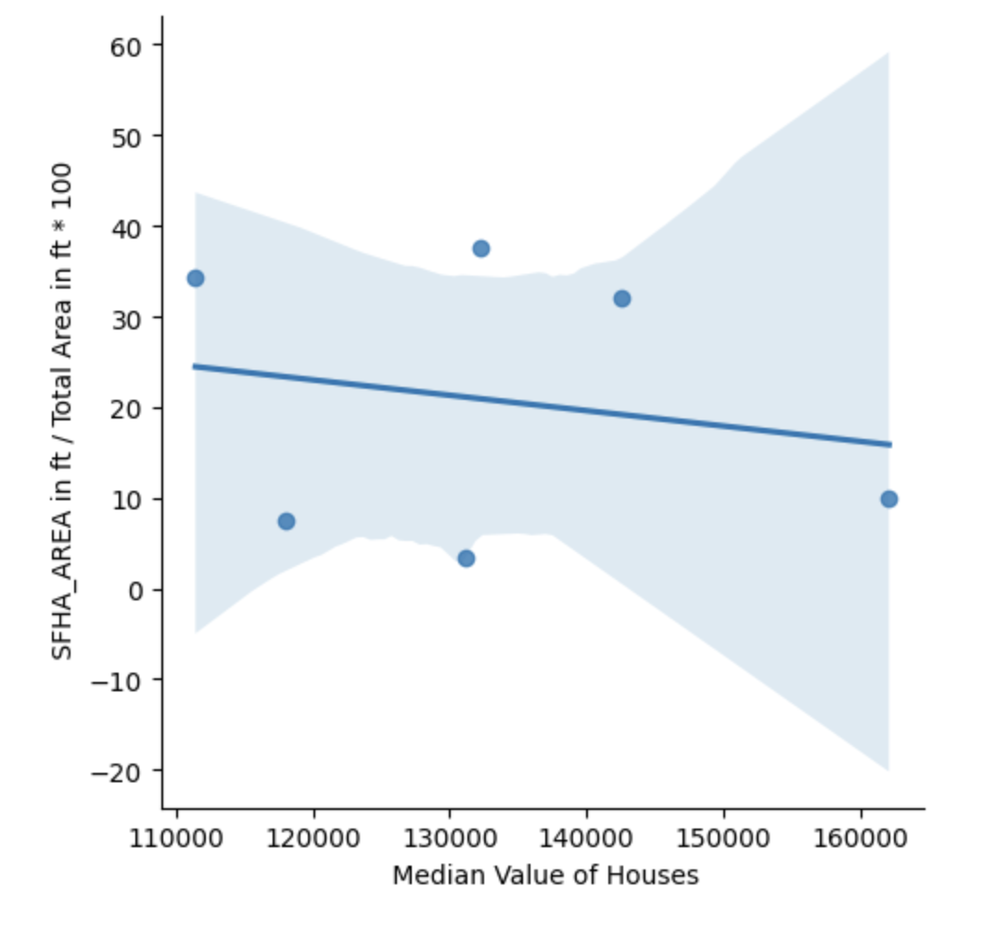

***Figure 4: Linear regression model between the percentage of the area of state designated as SFHA and the median value of owner occupied units in 2015 USD***

**Discussion**

Most data compiled and examined interestingly overlapped in results. The data collections, to no surprise, showed that coastal areas are more at risk for floods - shown from the correlation between low elevations and high SFHA percentages. Additionally, this relates to a major increase in flood risk in the future as variables like sea level rise and increased storm frequency are accounted for. Interestingly, Wilmington ranked for strongest correlation between flood risk and low income/percentage of non-white residents. Elizabeth City then Jacksonville followed for 2nd and 3rd ranked respectively. RTP, Charlotte, and Asheville consistently ranked lowest for flood risk and low income areas. However, the only section where this strays is the percentage of non-white residents. Predictably, larger cities such as RTP and Charlotte are more diverse than smaller cities. Overall, it was found that there is a correlation between flood risk and socioeconomic inequality in NC based on our areas of interest.

Additionally, it is worthy to note the difference in data caused by various layouts of map creations. While creating our projections, some decided to create a 30 mile buffer around the cities of interest, while others decided to create polygons. This difference is a result of where our data originated. Digitizing data from NC Spatial Download generates desired data from a “draw area” tool. Therefore it was easier to save this information as organic polygons. While data originating from census tracts are offered county-wise, therefore it is easier to compile data within a buffer. It is important to recognize how this disparity in data collection could cause our final correlations to be slightly-off.

Low income and primarily non-white communities are greatly impacted by inland flooding in North Carolina. While evaluating the data, elevation and income had the greatest contributions to risk of flooding and recovery time for these communities. This disparity will only become larger with climate change that would bring in increased temperatures and the frequency of tropical storms and flash floods (Handwerger, Sugg, and Runkle 2021). In NC, the projections indicate that sea levels by 2100 will have risen an estimated 1.3 to 2.4 feet under a moderate emission scenario and up to 2.0 to 3.6 feet under a high emissions scenario (Handwerger, Sugg, and Runkle 2021).

The disproportion in damage caused by flooding related to income shown in this study is not new to the US. Socioeconomic inequality has been the center point for other coastal and flooding research (e.g, SAMHSA 2017, Osberghaus 2021), and will continue to impact low income communities. Our results showed disproportionate exposure to flooding in high risk areas in correlation with low income and diverse demographics. To combat this climate injustice, more government intervention is needed to ensure vulnerable populations are being protected. The aim is to achieve equitable climate change resilience for flood risk communities and target areas in need of reformed mitigation plans in North Carolina.

**References**

“Disaster Technical Assistance Center Supplemental Research Bulletin Greater Impact: How Disasters Affect People of Low Socioeconomic Status.” SAMHSA. Substance Abuse and Mental Health Services Administration, July 2017. <https://www.samhsa.gov/sites/default/files/dtac/srb-low-ses_2.pdf>

Handwerger, Leah R., Margaret M. Sugg, and Jennifer D. Runkle. 2021 “Present and Future Sea Level Rise at the Intersection of Race and Poverty in the Carolinas: A Geospatial Analysis.” In *The Journal of Climate Change and Health* 3 <https://doi.org/10.1016/j.joclim.2021.100028>

“Katrina Impacts.” Hurricanes: Science and Society. Graduate School of Oceanography of the University of Rhode Island. Access date April, 2023 <http://www.hurricanescience.org/history/studies/katrinacase/impacts/#:~:text=Besides%20the%20death%20toll%2C%20hurricane,New%20Orleans%20showing%20flooding%20depths>

“Special Flood Hazard Area (SFHA).” IRMI. International Risk Management Institute. Access date April, 2023 <https://www.irmi.com/term/insurance-definitions/special-flood-hazard-area>

Osberghaus, Daniel. 2021 “Poorly Adapted but Nothing to Lose? A Study on the Flood Risk – Income Relationship with a Focus on Low-Income Households.” In *Climate Risk Management* 31 <https://doi.org/10.1016/j.crm.2020.100268>